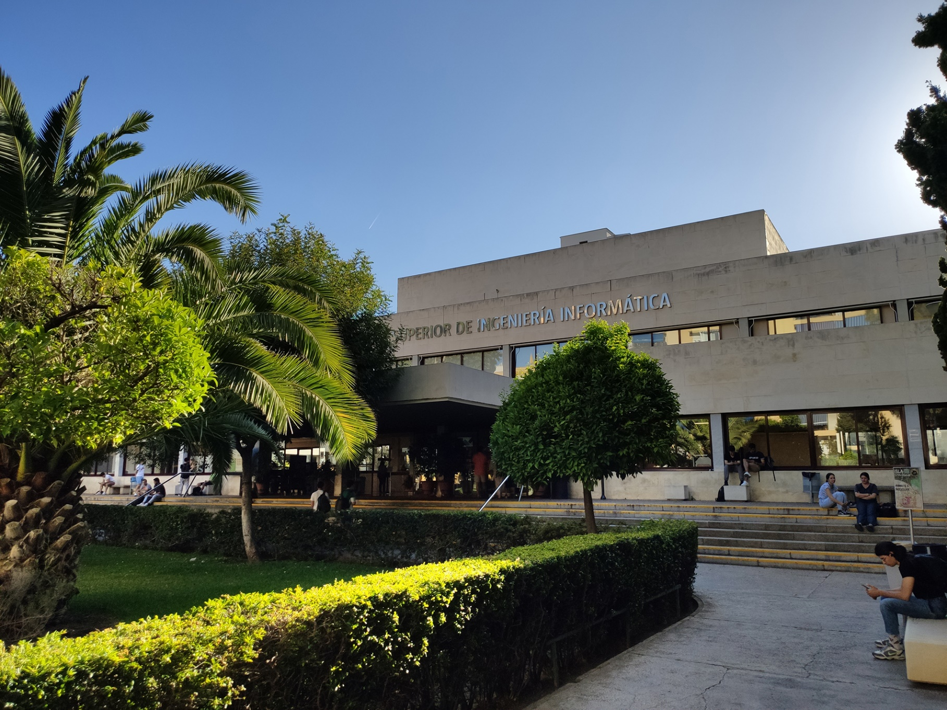

|  |
| --- |
| Analysis Report  Group |
| Adrián García-Baquero Porras  (adrgarpor@alumn.us.es) |
| 17-03-2023  Group: C1.02.10  Repository: https://github.com/IsmaelRuizJurado/Acme-L3-D02 |



Table of Contents

Executive Summary 3

Version History 4

Introduction 5

Contents 6

Conclusions 7

Bibliography 8

# Executive Summary

In this report you will find relative information of my deliverable in an Analysis Report structure. This document shows how many analyses record I have redacted, the content of those reports and a link to the forum where a lecturer gave us insight, if the requirement needed an outside help for interpretation.

# Version History

|  |  |  |
| --- | --- | --- |
| Version | Date | Description of changes |
| 1.0 | 17/03/2023 | Creation of the Analysis Report Document. |

# Introduction

This report presents an analysis of the requirements for the second deliverable of our project. The purpose of this analysis is to evaluate each requirement in depth in order to find the proper solution. In addition of our own analysis of each requirement, we have also taken into account any comments or feedback received in the project forum to ensure a comprehensive evaluation. By recording each analysis made to the requirements, this report ensures that all requirements are fully understood and accounted for in the project's development process.

# Contents

## Information Requirements

### Analysis of Requirement #1:

There is a new project-specific role called auditor, which has the following profile data: firm (not blank, shorter than 76 characters), professional ID (not blank, shorter than 26 characters), a list of certifications (not blank, shorter than 101 characters), and an optional link with further information.

I’ve created the role with no issues so far.

### Analysis of Requirement #2:

An audit is a document with auditing records regarding a published course. The system must store the following data about them: a code (pattern “[A-Z]{1,3}[0-9][0-9]{3}”, not blank, unique), a conclusion (not blank, shorter than 101 characters), some strong points (not blank, shorter than 101 characters), some weak points (not blank, shorter than 101 characters), and a mark (computed as the mode of the marks in the corresponding auditing records; ties must be broken arbitrarily if necessary).

From my point of view, it was logic that an audit would have access to its records so there sould be a OneToMany relationship with audit records there. But, the docent team has cleared this point for me so there’s no need to it and it’s only recommended to have a ManyToOne from the records to the document.

### Analysis of Requirement #3:

The system must store the following data about the auditing records of a course: a subject (not blank, shorter than 76 characters), an assessment (not blank, shorter than 101 characters), the pe-riod during which the subject was audited (in the past, at least one hour long),a mark (“A+”, “A”, “B”, “C”, “F”, or “F-“), and an optional link with further information.

As it refers to a course as well as audit document, I thought of pointing to the course from the records itself but after discussing it with my team and teacher, it was clear that Audit was the only one who needs the pointer to Course.

### Analysis of Requirement #4:

### The system must handle auditor dashboards with the following data: total number of audits that they have written for theory and hand-on courses; average, deviation, minimum, and maximum number of auditing records in their audits; average, deviation, minimum, and maximum time of the period lengths in their auditing records.

I’ve had no issues with this so far.

### Analysis of Requirement #5:

Produce assorted sample data to test your application informally. The data must include two auditor accounts with credentials “auditor1/auditor1” and “auditor2/auditor2”.

I’ve had no issues with this so far.

# Conclusions

# To sum up, we followed the theory material, listened to our teacher's advice, and took into account the feedback posted in the project forum. By doing so, we were able to work smarter, not harder, and produce a better result for the second deliverable. We're going to keep using these resources and the knowledge we've gained throughout the project to ensure we keep up the good work.

# Bibliography

Intentionally blank.